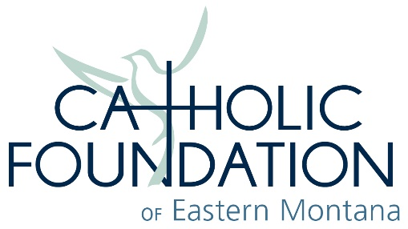
2019 Grant Application

Parish/Organization Name_____________________________________________________________________________
Address____________________________________________________________________________
Phone_____________________ Fax____________________ Email____________________________
Pastor/Chief Officer name and title ______________________________________________________
Grant Contact name and title___________________________________________________________
Grant Amount Requested $_____________ Grant Requested for (one sentence)__________________
___________________________________________________________________________________

NARRATIVE: Please provide the following information in narrative form and attach it to this application.
- Provide a complete description of the project/program/ministry need for which you are applying. Detail your expected outcomes.

- Explain why this need exists and how grant funding from the Foundation will help.

- Provide a description of your parish or organization, the population and community served by the particular parish, and project/ministry, and any unique challenges.

- Provide a budget (income and expenses) for your project/grant request. Be sure to note all other funding sources (outside of this hoped-for-grant). Also provide your timeline for project completion.

- If received, tell us how you will help promote this grant from the Catholic Foundation of Eastern Montana to your congregation/constituencies/Catholic community.

The undersigned Pastor/Administrator and/or authorized officer of the organization does hereby certify that the information set forth in this grant application is true and correct.
_______________________________________ ________________________________________
Signature Title
_______________________________________ ________________________________________
Printed Name Date

Send completed application to the Catholic Foundation of Eastern Montana, PO Box 1345, Great Falls, MT 59403. Envelope must be postmarked no late than Friday, October 18, 2019.

